P Rajasekhar
9035825113
rajasekharp212@gmail.com

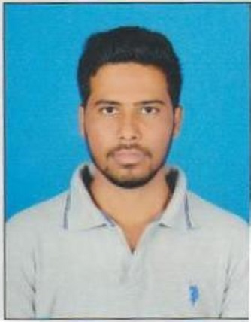

Experience Summary:

- IT professional with project experience around 4 years of experience in the IT industry and in the Mainframe technology with strong technical experience in Mainframe technologies and functional experience in Telecom Domain.
- Hands on experience on mainframe development, testing and production support projects.
- Currently working as a Software Developer at TCS, August 2018 to till date.

Mainframe Expertise:

- Extensive experience in Mainframe technologies - JCL, COBOL, VSAM, DB2, CICS.
- Analyzing business needs from clients to implement it correctly by creating the business rules.
- Helping the developers to modify, and implement the changes to various programs
- Developing use cases and design alternatives in accordance with business requirements
- Participating in business discussion, writing specifications code reviews, working with programmers and clients, to effectively document and validate all implementations.
- Creating test plan to test all possible scenarios to ensure that the changes made to the system are correct and are tested and ready to be moved into production.
- Coordinating with user groups for post implementation support.
- Experience in SDLC and STLC process.
- Maintaining the quality in every phase of SDLC to exceed customer expectations.
- Proficient in using mainframe tools like Changeman, File Aid, LINUX,IBM Debugger, and SPUFI.
- Test analysis and test execution skills in mainframe testing.

Technical Skills:

- Language/Interface : JCL, COBOL,VSAM.
- DBMS : DB2
- Front End/GUI : CICS, MS-Office (Word, Excel, PowerPoint)
- OS/Environment : Z/OS, Windows 2000/XP
- Tools : Changeman, File-aid, IBM Debugger, SPUFI
- Testing : Unit, Function, Integration, Regression, ,DB2-SPUFI,DB2-SQL.

Project Experience:
- Client : West Field Insurance, Ohio
- Project Title : West field AMS
- Role : Software Developer
- Team Size : 10
- Duration : Oct 2018 – Till date
- Environment : COBOL, JCL, DB2, CICS,LINUX
- Client Description:
Westfield Insurance located at Westfield center, Ohio, U.S.A is in Insurance business since 1848 offering Property and Casualty Insurance products. Primary areas of its interest include personal
and commercial lines of insurance. Westfield Companies use PMS product developed by Policy Management System Corporation. The Westfield IT department extensively enhanced PMS product to suit their needs.
PMS product cover operations that support the Data Entry, Policy processing, Printing of policies, Claims,
Billing, Bond Contractors Policy processing, Production Records, Month-end and Statutory reporting of
Westfield Companies.

Roles & Responsibilities:

- Analysis the SDS (System design specification) document.
- Database management using DB2 and VSAM.
- An Executed UTP is designed with unit and regression test cases in order to prove the test results coming as per the expect.
- Understanding the application, interface and business involved on the requirement by interacting with onsite coordinator and clients.
- Test the components thoroughly before moving to the production.
- Co-ordinate with on-shore counterpart on day to day basis and take/provide handover of tasks/activities at the beginning/end of the day.
- Providing full lifecycle support from requirements analysis through design, coding, testing, debugging, implementation and integration.

Declaration:

- I hereby declare that the above information provided is true to the best of my Knowledge.

( P.Rajasekhar)

